Brett Fuller

CSD 380 - Assignment 5.2

6/28/2025

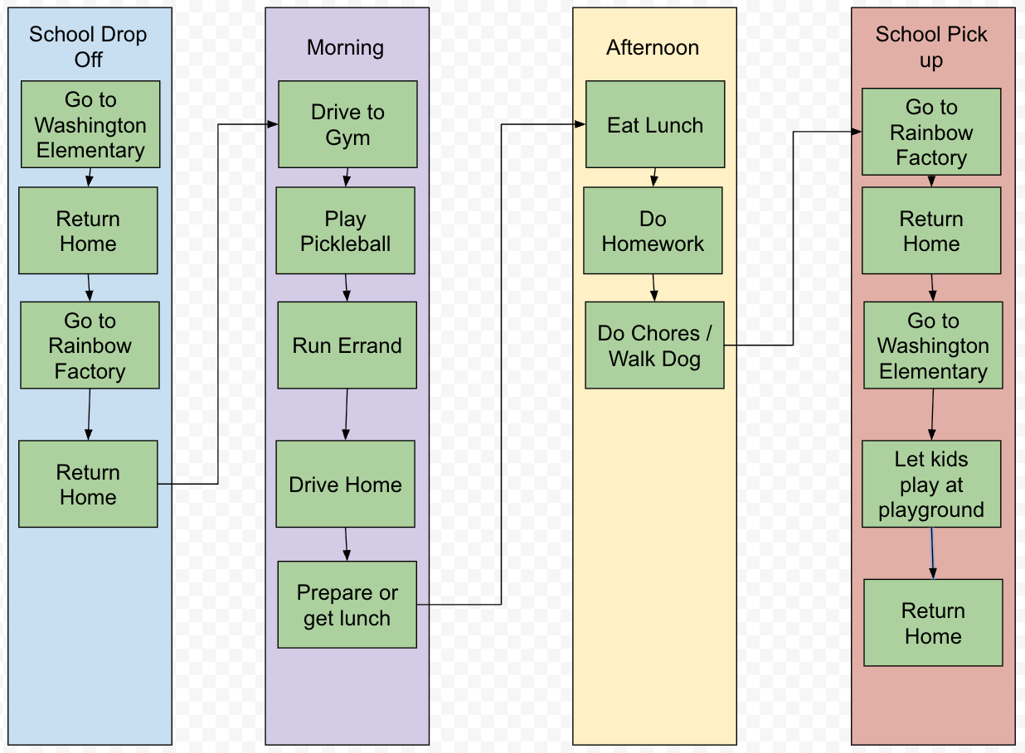

Breakdown of tasks due over the course of a week and time spent on tasks and preferred activities.

—---------------------------

Weekday Kid drop off entertainment and school work.

Drop off Henry at Elementary School 30 minute round trip walk doors open at 8:30, Classes start at 8:50.

Drop off Hudson at Preschool. Round trip driving 30 minutes. Classes begin at 9:00.

Pickleball Open play. Ideally I would play 10 hours a week. So 2 hours of pickleball a day and 45 minutes round trip driving.

Preschool pickup 3:00pm. 30 minutes round trip driving.

Elementary school pickup and kid park play time 75 minutes. Pickup at 4:00pm.

School work:

Reading approximately 5 hours per week. Due Thursday so that discussion boards can include that material

Programming approximately: 4 hours per week

Writing Assignments approximately 4 hours per week.

Discussion board posts: due Thursday approx 4 hours per week.

Discussion board replies: due Sunday approx 1 hours per week.

Summary of activities and time available.

—-----------------------------

WeekDay hours 8:15 - 5pm = 8.75 hrs

—-----------------------------

| Activity | Minutes | Hours |
| --- | --- | --- |
| Kids School |  |  |
| Travel Time | 120 | 2 |
| Playground | 45 | 0.75 |
| Pickelball |  |  |
| Travel Time | 45 | 0.75 |
| Play | 120 | 2 |
| My School |  |  |
| Reading | 60 | 1 |
| Work | 180 | 3 |
| Chores & Errands | 60 | 1 |
| Lunch | 60 | 1 |
| Total | 690 | 11.5 |

—---------------------------

Results Breakdown

—---------------------------

Unfortunately my available hours means that with my current scheduling I need to move some of my homework and chores into the weekend, and typically give up 2 - 4 hours of pickleball a week which I find getting those 2 hours of pickleball in a day really helps me feel healthier physically and mentally. I also end up doing a lot of School work on evenings and over the weekend. Ideally I would like to continue to play pickleball on the weekdays without giving up my family time on the weekends while also doing a good job on my homework.

—----------------------------

Potential Optimizations

—----------------------------

I could optimize time by removing a lot of the trips back home between tasks. If I go from one drop off to the next I can save approximately 1 hour each day, and if I then go directly from drop off to the gym and then run errands and grab lunch on my way home from the gym I can probably save another 15 minutes a day. From there I can probably get more use out of my travel time daily by utilizing audio books for my class materials and could take care of a great deal of my required reading during my daily drives. One other optimization might be to increase my daily pickleball play time to 2.5 hours and play 4 days a week allowing me to play the same amount but further reduce travel time by not having to drive to and from the gym on that one day. Optimizing my time like this could reduce the need to do my homework on evenings and weekends to only a couple of hours instead of taking the majority of a weekend day.

| Activity | Minutes | Hours |
| --- | --- | --- |
| Kids School |  |  |
| Travel Time | 60 | 1 |
| Playground | 45 | 0.75 |
| Pickelball |  |  |
| Travel Time | 30 | 0.5 |
| Play | 120 | 2 |
| My School |  |  |
| Reading | 0 | 0 |
| Work | 180 | 3 |
| Chores & Errands | 60 | 1 |
| Lunch | 60 | 1 |
| Total | 555 | 9.25 |

With this optimized schedule I would have only a few hours of work to make up for on the evenings and weekends which would allow me to spend more time doing what I enjoy.

